
Saad Mughal
F2023-009
Total Marks: 10
Due 29 April 2026

Computer Networks LAB

Week 10

Network Configuration

Course Lecturer: Shaiza Rizwan
Lab Instructor: Hasnain Ahmad
Section: C

Computer Networks LAB (LAB-209) - Lab 08
Network Configuration

Task 1-5
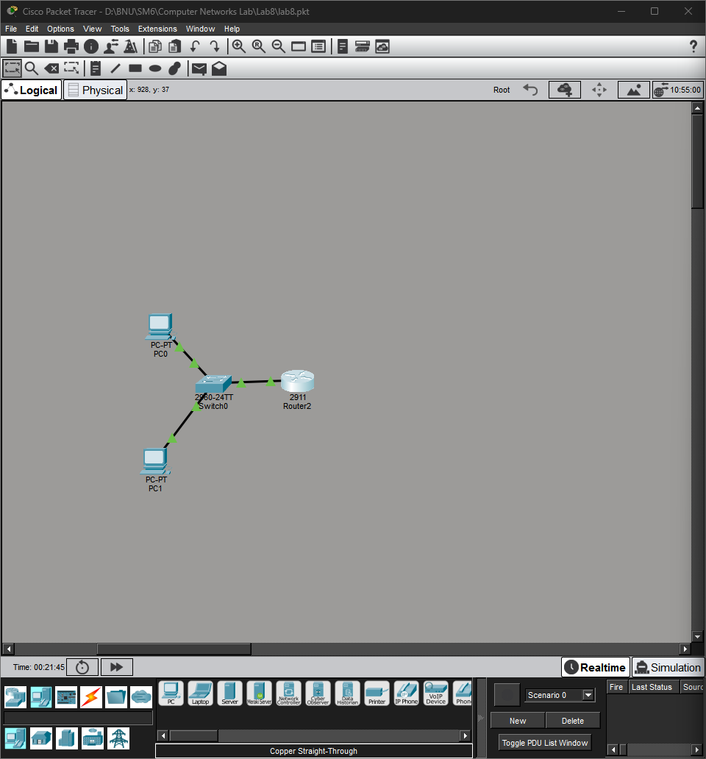
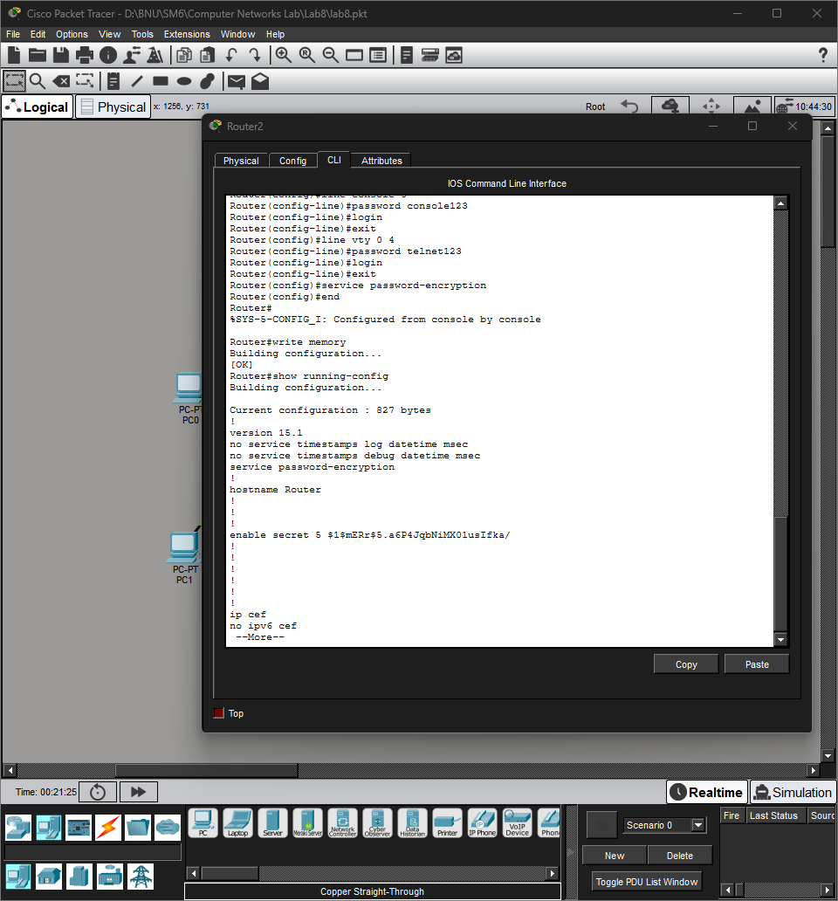
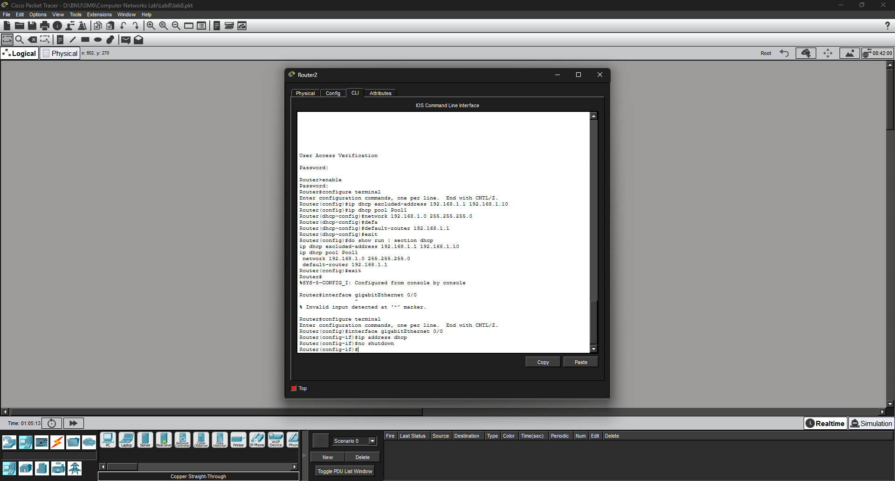
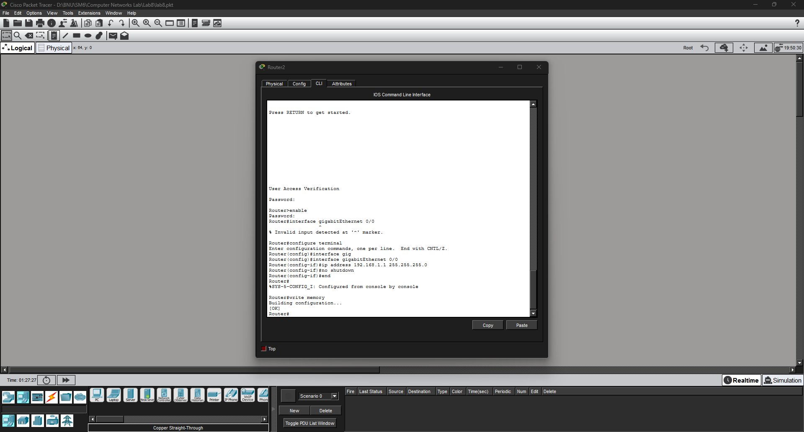
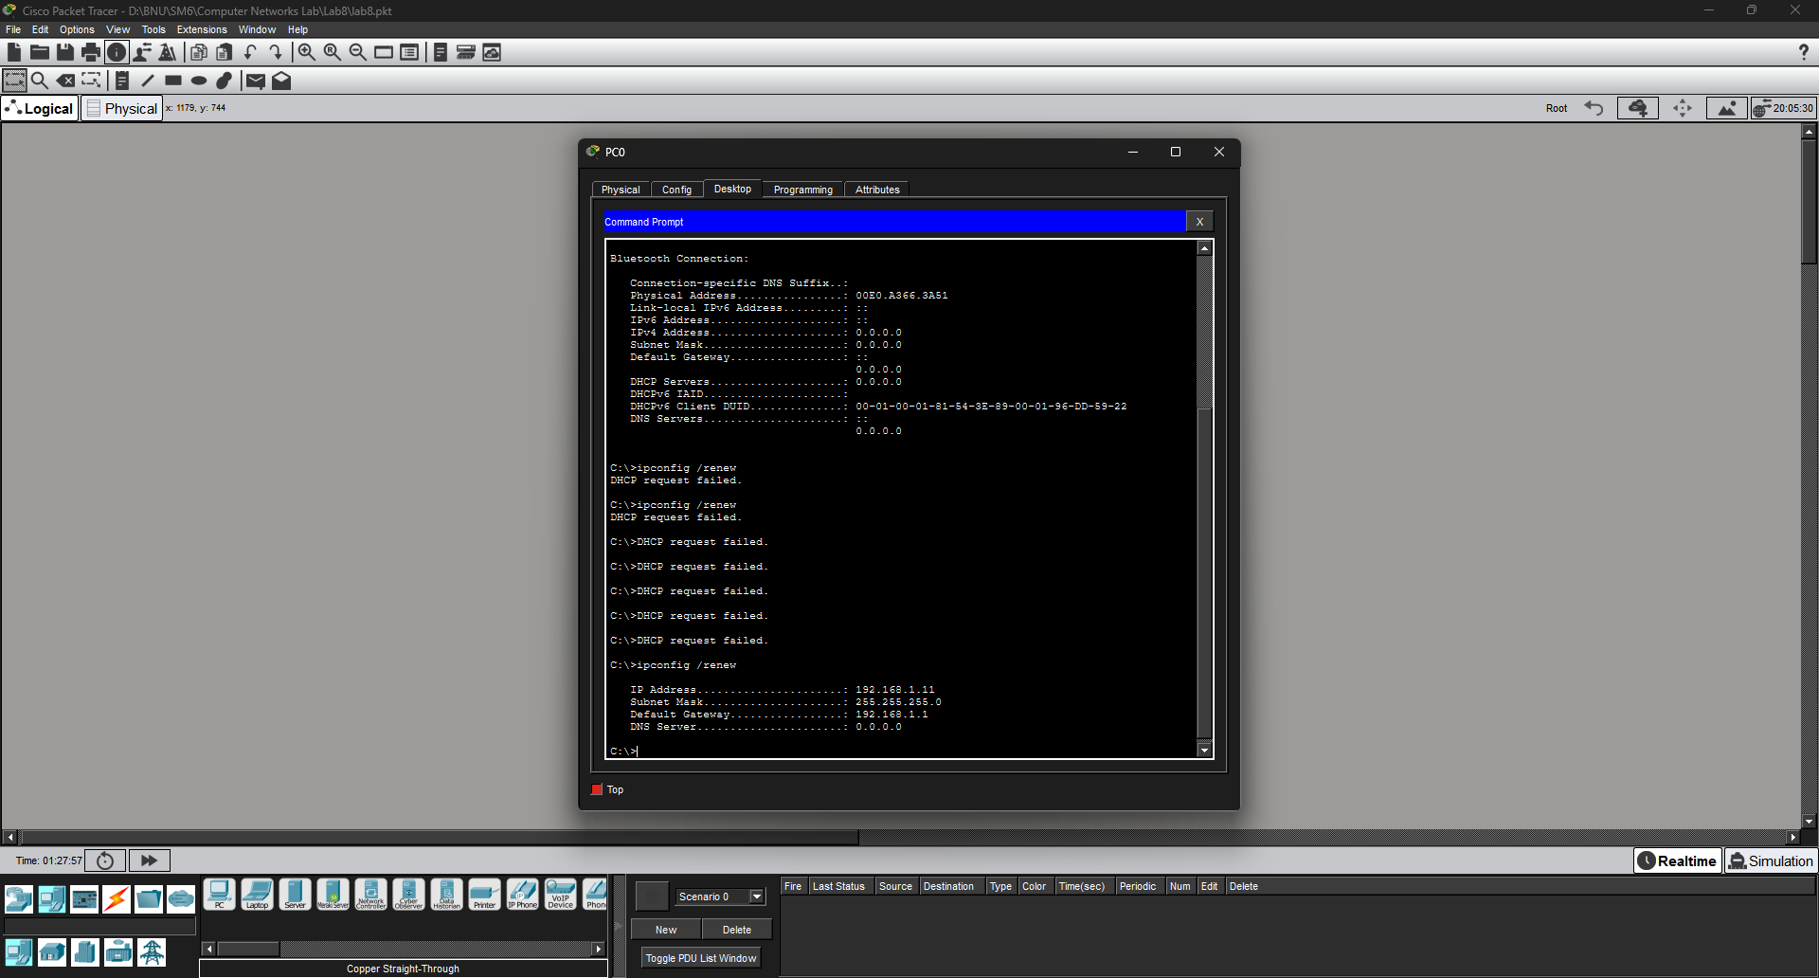
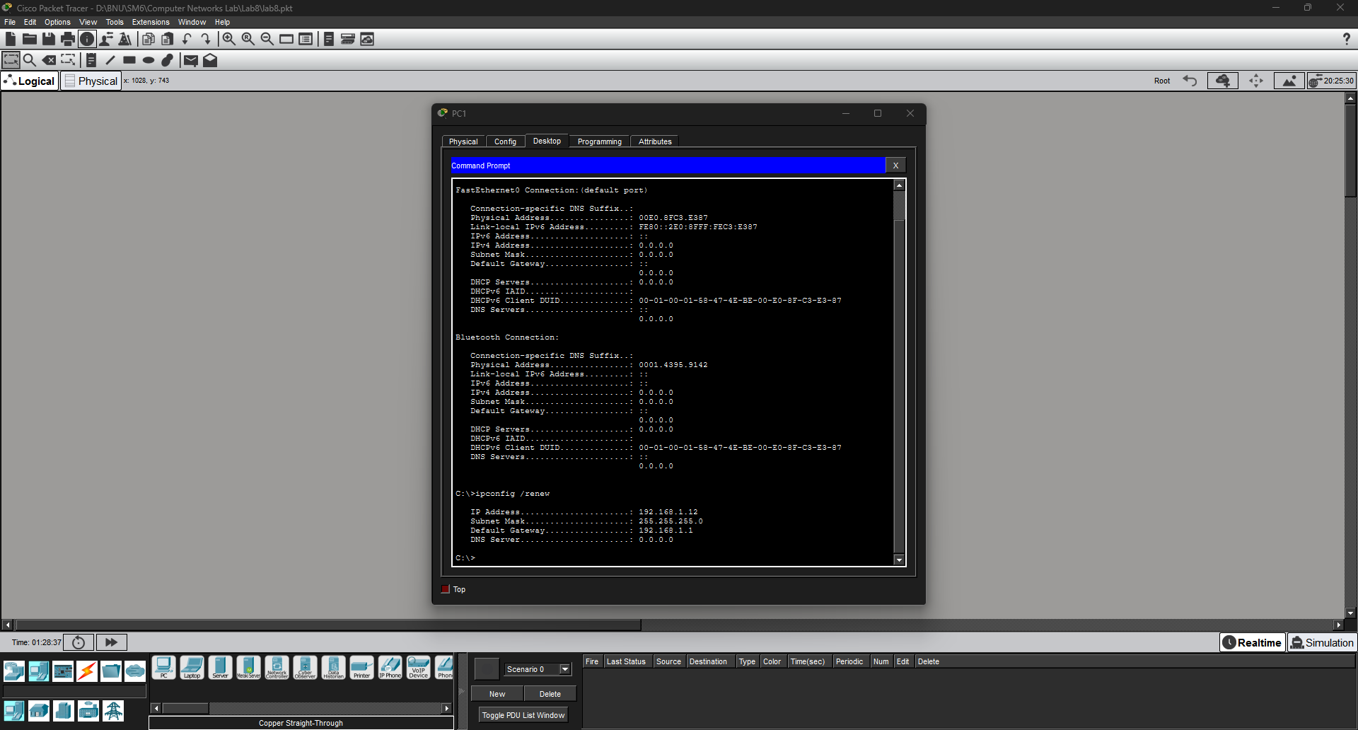
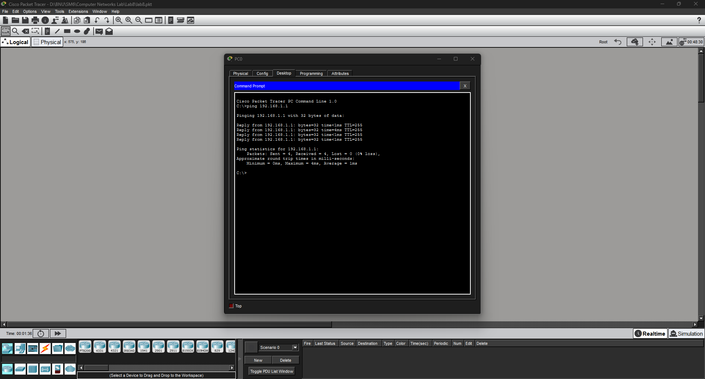
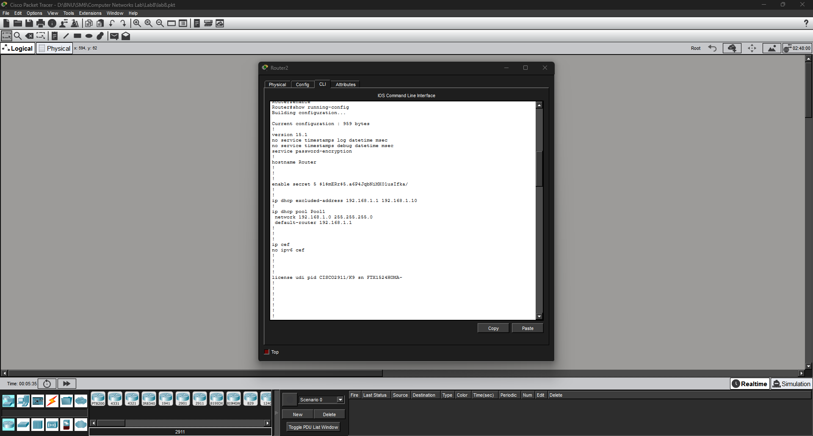
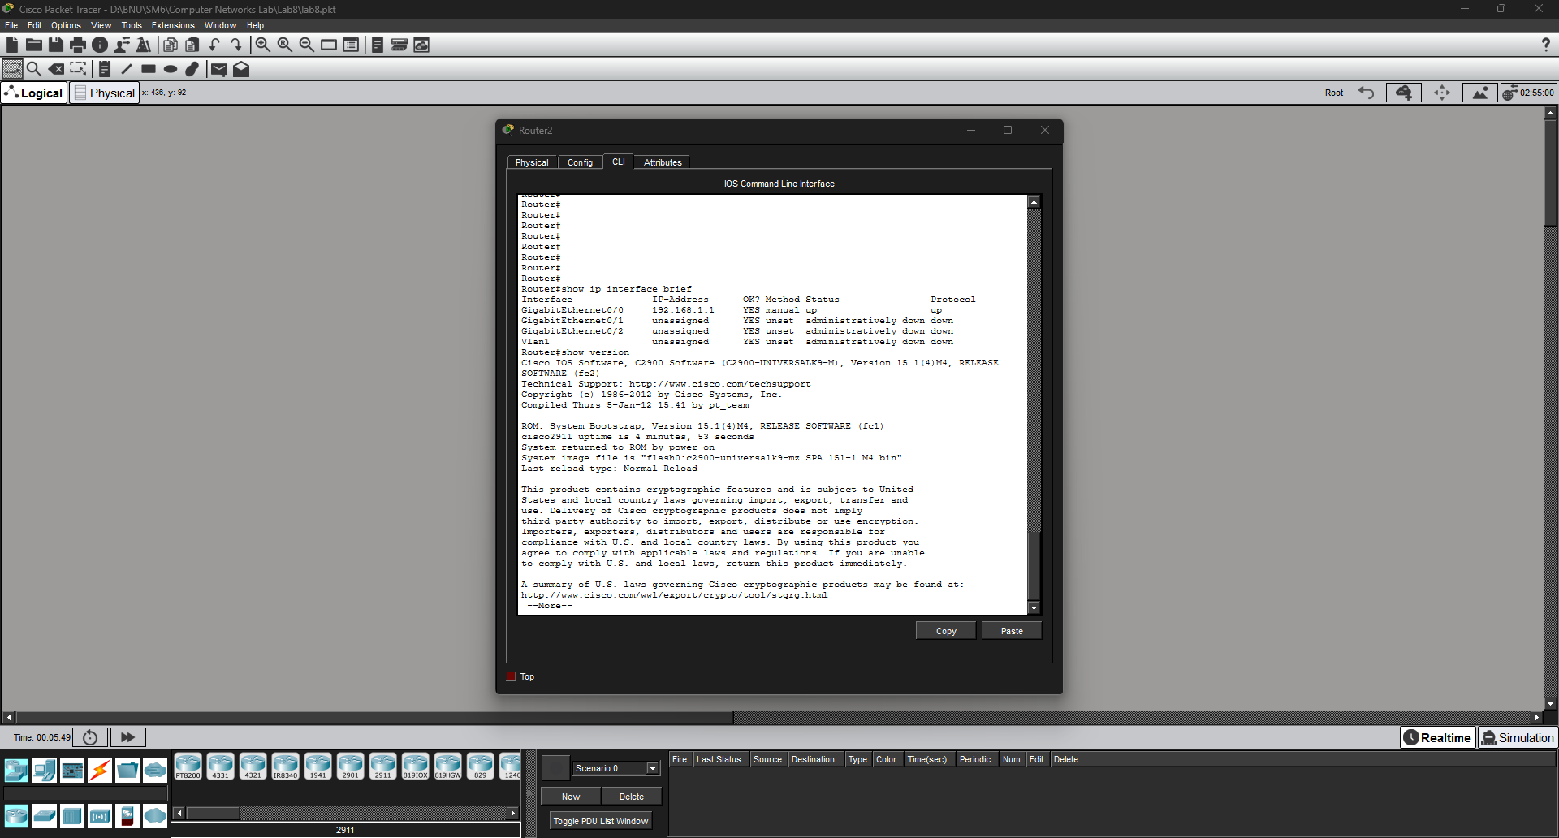
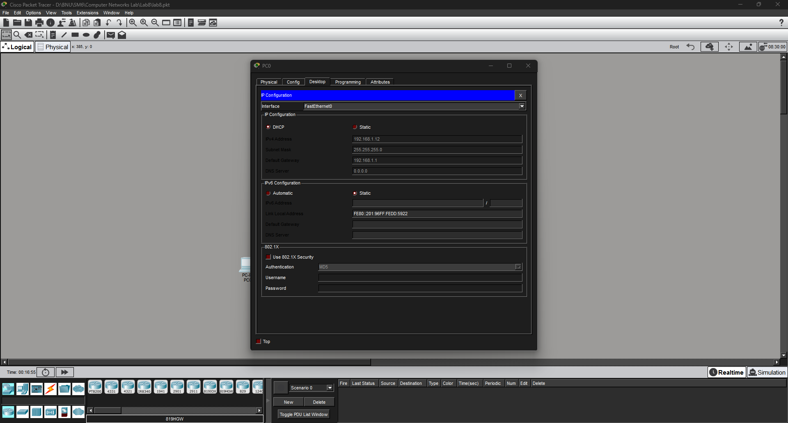
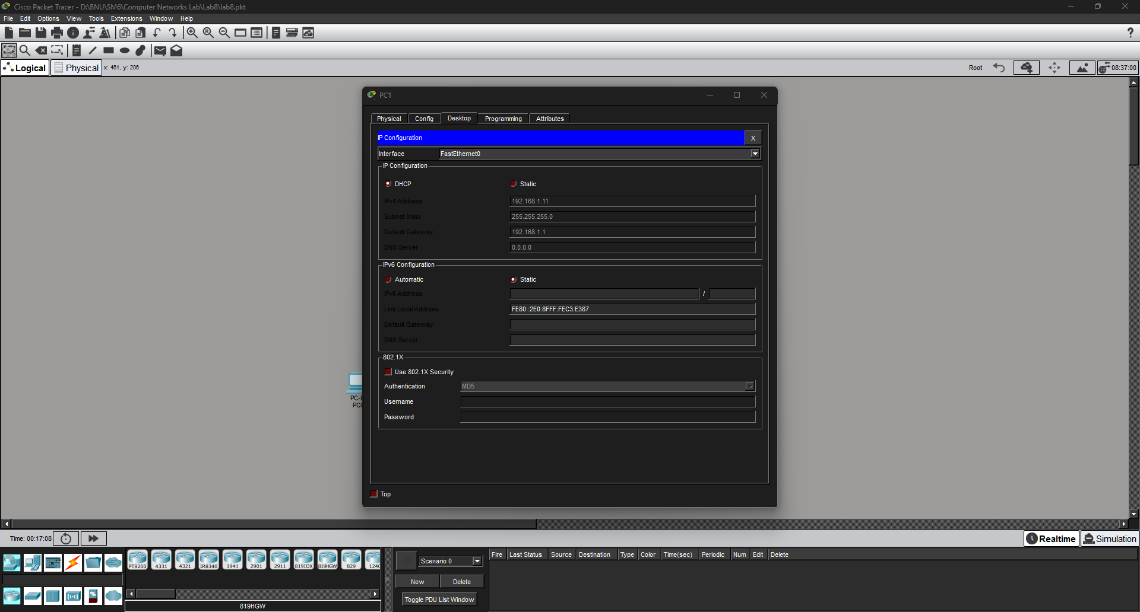

Task 6
- Write down the exact commands you used to set the hostname and passwords on HQ-Router:
Router> enable
Router# configure terminal
Router(config)# hostname HQ-Router
HQ-Router(config)# enable secret class
HQ-Router(config)# line console 0
HQ-Router(config-line)# password cisco
HQ-Router(config-line)# login
HQ-Router(config-line)# exit
- Write down the exact commands you used to assign the IP address to GigabitEthernet0/0:
HQ-Router(config)# interface gig
HQ-Router(config)# interface GigabitEthernet0/0
HQ-Router(config-if)# ip address 10.0.0.1 255.255.255.0
HQ-Router(config-if)# no shutdown
HQ-Router(config-if)# exit
Write memory
- Copy the output of 'show ip interface brief' from your router CLI here:
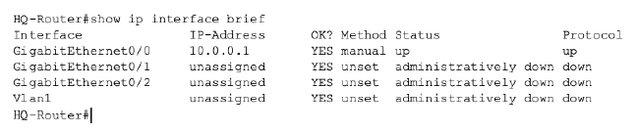
- Ping Test Results:
Ping Test | Packet Sent | Packet Received | Pass/Fail
PC-Admin pings Router (10.0.0.1) | 4 | 4 | Pass
PC-Sales pings Router (10.0.0.1) | 4 | 4 | Pass
PC-Admin pings PC-Sales (10.0.0.20) | 4 | 4 | Pass
PC-Sales pings PC-Admin (10.0.0.10) | 4 | 4 | Pass

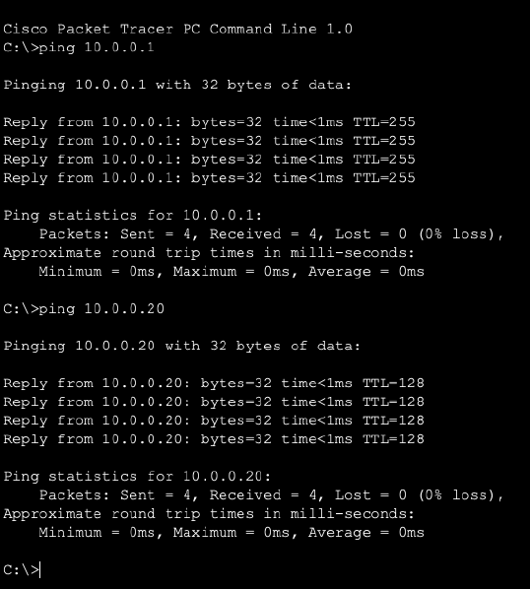
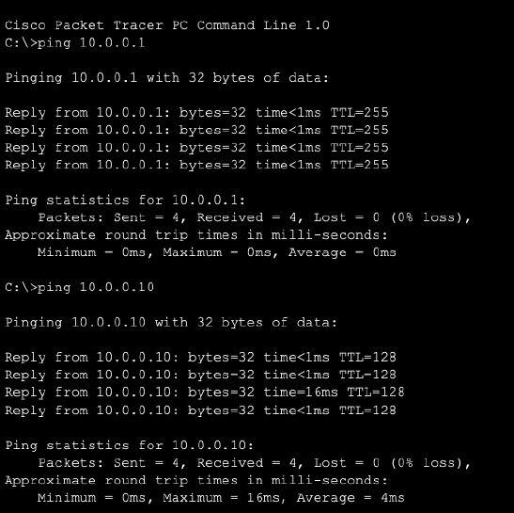

- From 'show running-config', write the lines that confirm your hostname and passwords
HQ-Router#show running-config
Building configuration...

Current configuration : 784 bytes
!
version 15.1
no service timestamps log datetime msec
no service timestamps debug datetime msec
service password-encryption
!
hostname HQ-Router
!
!
!
enable secret 5 $1$mERr$9cTjUIEqNGurQiFU.ZeCi1
!
!
!
!
!
!
ip cef
no ipv6 cef
